NUCL 510 HMWK 5

*In plotting these functions, it was made apparent that the values for $μ_{c}$ were incorrectly calculated, although they were calculated directly out of the lecture notes (Lecture 02, Slide 12). This is the reason for the discrepancy between these charts and the charts in the notes that should be identical.*

1. Energy Distribution of scattered neutrons

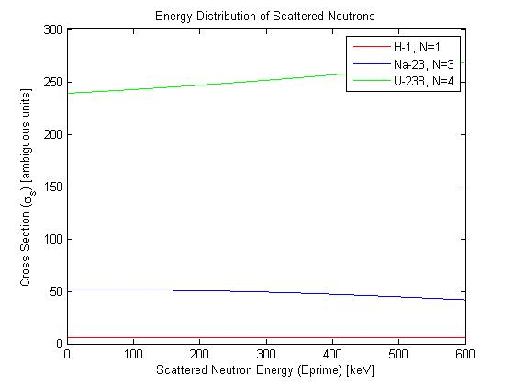

Figure 1 Energy Distribution of Scattered Neutrons (for different isotopes)

function [sigma_s]=energydistributionscatteringcrosssection(isotope)

E=600;

Eprime=linspace(0,600,1000);

Q=0;

fn=[1,1,1;...

-1.38363E-03,2.50710E-01,1.08577E-01;...

Inf,1.36480E-01,9.09901E-03;...

Inf,-3.77540E-03,4.24348E-04;...

Inf,Inf,1.13003E-05];

if(isotope==1)

N=1;

A=1;

sigma_se=5.6;

elseif(isotope==2)

N=3;

A=23;

sigma_se=3;

else

N=4;

A=238;

sigma_se=5.9;

end

beta=A*sqrt(1-((1+A)/A*(-Q)/(E)));

muc=((Eprime/E)*((1+A)^2)-1-(beta^2))./(2*A*beta);

alpha=((A-1)/(A+1))^2;

sigma_s=0;

for n=0:N

P=legendre(n,muc);

Psum=sum(P,1);

f=fn(n+1,isotope);

sigma_s=sigma_s+(((2*n)+1).*f.*Psum);

end

sigma_s=sigma_s*((sigma_se/(1-alpha)));

1. Legendre expansion order up to L=5 for the scattering transfer cross section

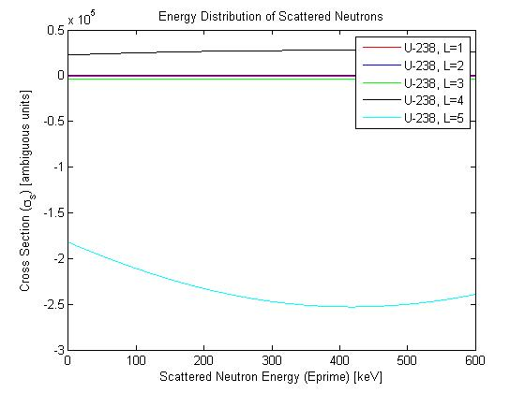

Figure 2 Energy Distribution of Scattered Neutrons (for different legendre orders)

function [sigma_s]=energydistributionscatteringcrosssectionpl(L)

isotope=3;

E=600;

Eprime=linspace(0,600,1000);

Q=0;

fn=[1,1,1;...

-1.38363E-03,2.50710E-01,1.08577E-01;...

Inf,1.36480E-01,9.09901E-03;...

Inf,-3.77540E-03,4.24348E-04;...

Inf,Inf,1.13003E-05];

N=L-1;

A=238;

sigma_se=5.9;

beta=A*sqrt(1-((1+A)/A*(-Q)/(E)));

muc=((Eprime/E)*((1+A)^2)-1-(beta^2))./(2*A*beta);

alpha=((A-1)/(A+1))^2;

sigma_s=0;

Pl=legendre(L,muc);

Plsum=sum(Pl,1);

for n=0:N

P=legendre(n,muc);

Psum=sum(P,1);

f=fn(n+1,isotope);

sigma_s=sigma_s+(((2*n)+1).*f.*Psum);

end

sigma_s=sigma_s .*Plsum.*((sigma_se/(1-alpha)));